Web Development (Intermediate)
WEDE6021
POE : Part 1



Group Members:
Armalene Magerman : ST10454097
Chloe Langenhoven: ST10435895
Rafiqah Kirby: ST10438554

Due date : 14 April 2026

SECTION 1 - Research

Table of Contents
Section 1: Introduction 3
2. Research on Web Applications 3
2.1 Overview of Web Applications 3
Vakoop 3
Seconds To Go 4
2.2 Strengths and Weaknesses 4
Vakoop 4
Seconds To Go 5
2.3 Innovative Features 5
Vakoop: 5
Seconds To Go: 5
Technical Insight: 5
2.4 UX Design 6
Mobile Friendliness 6
Layout and Design 6
Performance 6
Navigation 6
3. Visual(infographic) comparison between both web applications 6
4. Best Features to Include in Pastimes 7
Key Features 7
Conclusion 8
References. 8

Section 1: Introduction
The rapid advancement of technology and the widespread availability of the internet have significantly transformed the global retail industry. In recent years, e-commerce has become a dominant method of buying and selling goods, offering convenience, accessibility, and efficiency to both businesses and consumers. This shift was further accelerated during the COVID-19 pandemic, where physical shopping was restricted, forcing many consumers to rely on online platforms. As a result, online marketplaces have continued to grow even in the post-pandemic era.
One of the fastest-growing sectors within e-commerce is the resale of second-hand clothing. This trend is driven by several factors, including affordability, environmental awareness, and the increasing demand for sustainable fashion. Consumers are becoming more conscious of the environmental impact of fast fashion and are therefore turning to second-hand platforms as a more eco-friendly alternative. These platforms also provide an opportunity for individuals to generate income by selling pre-owned clothing that is still in good condition.
In South Africa, the growth of online second-hand clothing platforms has created new opportunities for both buyers and sellers. These platforms enable users to easily list items for sale, browse available products, and communicate with other users. However, the effectiveness of such platforms depends heavily on their usability, security, and overall user experience.
This report aims to analyse two existing online second-hand clothing platforms and evaluate their features, strengths, weaknesses, and user experience design. The purpose of this research is to identify best practices and innovative features that can be incorporated into the development of the Pastimes web application. By understanding how existing systems operate, it becomes possible to design a more efficient, user-friendly, and secure platform that meets the needs of modern users.

2. Research on Web Applications

2.1 Overview of Web Applications

Vakoop
Vakoop is a South African online marketplace designed to facilitate the buying and selling of second-hand items, particularly branded clothing, sneakers, and accessories. It operates using a peer-to-peer (P2P) model, where users act as both buyers and sellers. This allows for a dynamic and scalable platform where inventory is continuously updated by users.
The system enables sellers to upload product details such as images, descriptions, price, and condition. Buyers can browse listings, filter items based on categories, and complete purchases securely through the platform.
A key feature of Vakoop is its authentication system, where certain high-value branded items are verified before being sold. This increases trust and reduces the risk of counterfeit products.
From a technical perspective, Vakoop likely uses:
- A relational database (e.g., MySQL) for storing user and product data
- Secure APIs for payment processing
- Image storage systems for handling product images
- Backend validation for managing listings
- Seconds To Go

Seconds To Go
Seconds To Go is a curated South African online thrift store that focuses on high-quality, second-hand clothing. Unlike Vakoop, it follows a business-to-consumer (B2C) model, where the platform itself manages and uploads all items.
The system ensures that all clothing items meet certain quality standards before being listed. This results in a more controlled and reliable shopping experience for users.
The platform is designed with simplicity in mind, offering:
- Clean product displays
- Easy navigation
- Minimal clutter
- Straightforward checkout process
From a system design perspective:
- Inventory is centrally managed
- There is no direct user-to-user interaction
- Database structure is simpler compared to P2P systems

2.2 Strengths and Weaknesses

Vakoop

Strengths:
- Highly interactive platform allowing user participation
- Large variety of products due to user-generated listings
- Secure payment integration
- Authentication improves trust

Weaknesses:
- Quality inconsistency due to user uploads
- Requires moderation to prevent fraud
- More complex system design
- Seconds To Go

Seconds To Go

Strengths:
- High-quality, curated products
- Simple and easy-to-use interface
- Reliable shopping experience
- Minimal risk of fraudulent listings

Weaknesses:
- Limited product availability
- No seller participation
- Less scalable compared to P2P platforms

2.3 Innovative Features

Vakoop:
- Built specifically for the South African market
- Secure wallet payment system
- Authentication for branded/luxury items

Seconds To Go:
- Curated collections (quality over quantity)
- Focus on sustainability and eco-friendly fashion
- Unique “limited drop” style inventory

Technical Insight:
These features show the use of:
- Secure payment integration
- Data validation systems
- Inventory management systems

2.4 UX Design

Mobile Friendliness
Both platforms are mobile-friendly, allowing users to browse and purchase items on smartphones, which is important in South Africa where many users rely on mobile devices.

Layout and Design
Vakoop: More complex due to multiple categories and listings
Seconds To Go: Clean and minimalistic design

Performance
Both websites load relatively quickly, although performance may depend on image sizes and internet speed.

Navigation
Vakoop: Advanced navigation with filters
Seconds To Go: Simple navigation with fewer options

3. Visual(infographic) comparison between both web applications
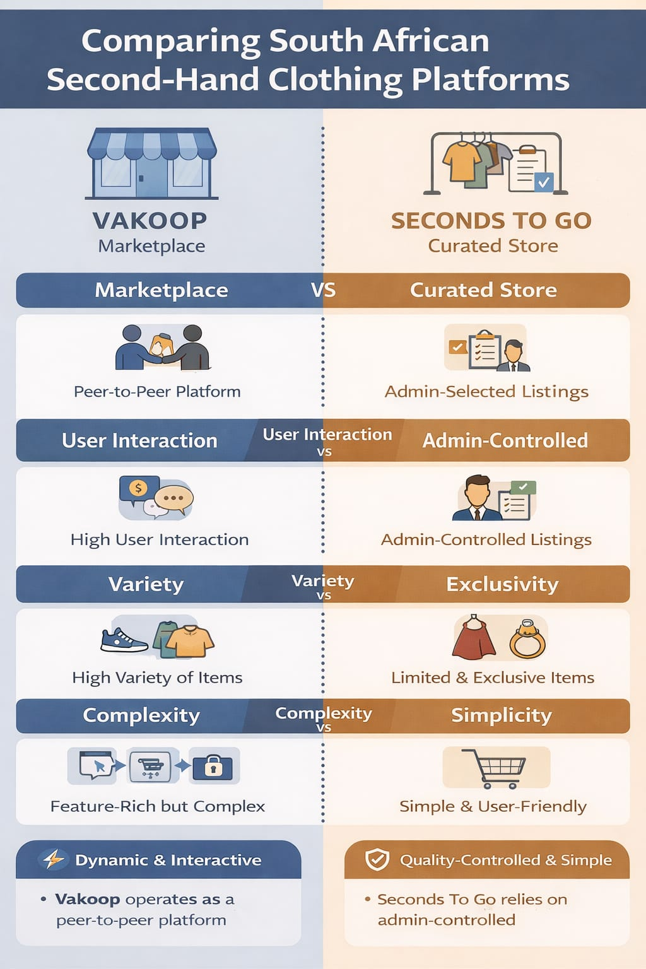

4. Best Features to Include in Pastimes
Based on the research conducted, the Pastimes web application will incorporate a hybrid approach, combining the strengths of both platforms.

Key Features

User Authentication System
- Secure registration and login using validated credentials.

Seller Verification System
- Admin must approve sellers before allowing uploads. This ensures trust and reduces fraudulent activity.

Product Listing System
- Sellers can upload items with images, descriptions, price, and condition.

Admin Approval of Listings
- Products must be approved before appearing on the platform.

Shopping Cart System
- Users can add, remove, and update items before purchasing.

Messaging System
- Buyers can communicate directly with sellers regarding products.

Search and Filtering
- Users can filter products based on size, brand, price, and condition.

Responsive UI Design
- The platform will be mobile-friendly and easy to navigate.

Technical Justification

These features support key concepts such as:
- CRUD operations
- Session management
- Database normalization
- Input validation and security

Conclusion
The analysis of existing second-hand clothing platforms has highlighted the importance of designing systems that balance usability, functionality, and security. Platforms such as Vakoop and Seconds To Go demonstrate different approaches to online retail, with one focusing on user interaction and scalability, and the other prioritising quality control and simplicity.
The research shows that no single platform is perfect; instead, each system has strengths that can be combined to create a more effective solution. By adopting a hybrid approach, the Pastimes web application can provide both flexibility for sellers and a secure, reliable environment for buyers.
Furthermore, the inclusion of features such as seller verification, admin approval of listings, and user communication will improve trust and overall user experience. These elements are essential in ensuring the success of an online marketplace, particularly in a competitive and growing industry.
In conclusion, this research provides a solid foundation for the design and development of the Pastimes web application. It ensures that the system will meet user needs while following best practices in software development and web application design.

References.
- Laudon, K.C. and Laudon, J.P., 2020. Management Information Systems: Managing the Digital Firm. 16th ed. Harlow: Pearson.
- Pressman, R.S. and Maxim, B.R., 2020. Software Engineering: A Practitioner’s Approach. 9th ed. New York: McGraw-Hill.
- Seconds To Go, 2026. Online thrift store. Available at: https://secondstogothrift.com (Accessed: 13 April 2026).
- Thrift by Pangape, 2026. Online thrift store South Africa. Available at: https://thrift.pangape.co.za/ (Accessed: 13 April 2026).
- Unsplash, 2026. Free fashion and clothing images. [online] Available at: https://www.unsplash.com (Accessed: 14 April 2026).
- Vakoop, 2026. South African preloved marketplace. Available at: https://vakoop.co.za (Accessed: 13 April 2026).

